**CHAPTER 3**

**SOFTWARE DEVELOPMENT METHODOLOGY**

**Introduction**

This chapter, presents the software development approach that was used as a guide in this project. This chapter includes Software Design and Development Approach, Constraints, Assumptions, Risk and Minimization, and Project Schedule Testing and Evaluation Procedures.

**SOFTWARE DESIGN AND DEVELOPMENT APPROACH**

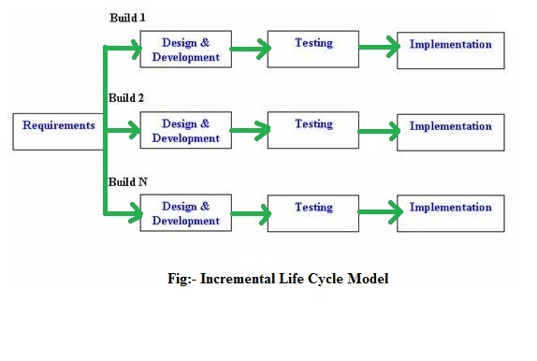

*Figure (52): General Framework of Incremental Development*

Incremental Development method was the software development methodologies that was used as a guideline for the project, wherein the accomplished project depended on the group effort between committed, independent, and communicative team members. It promoted adaptive planning, fast development, early delivery, constant progress, and promotes rapid and flexible response to adjustments.

Incremental Methodology is an alternative to traditional project management usually used in software development. It helps teams to respond to a certain change of the project through incremental works. Incremental Methodology is an alternative to waterfall, or traditional sequential development.

Incremental is a combination of waterfall model and iterative in prototyping model, each development is broken down into small pieces each of which the requirements of the product are designed, implemented and tested incrementally. The product is also divided into a number of standalone modules wherein it is designed and built separately.

Incremental constructs a partial implementation of a total system, called Modules. The functionality is then slowly added, the customer may require a certain functionality and it will be added later on. The top priority of the system is always the first one to be made and delivered. Each module is always better than the previous one for more functionality is added until the system and the design is fully implemented.

Every increment conveys fast and an operational product in which the customer can validate every module and provide a feedback. If changes are requested by the customer, incremental methodology can accommodate it easily. The product is considered finished when all of the requirements are satisfied and completed.

Incremental has 4 phases to complete every module of the system; these were repeated throughout the project until the system is fully implemented and the client is satisfied with the product. These 4 phases are; Requirement Analysis, Design and Development, Testing and Implementation.

**Requirement Analysis**

In this phase the requirements and specifications are understood and identified. This phase is one of the crucial parts of the system, for it involves all the necessary information of the company's manual reservation system and billing system. The collected information was then used for attaining the wants and needs, satisfaction and convenience of the customers for the reservation system. The requirements were gathered by a series of interviews with potentially users or customers. This necessary information helps in developing the ideal system in performing a day to day business processes of the customer.

**Design and Development Phase**

In this phase the system’s design and functionality was particularly decided and well-thought about, in this part the design of the system and functions were added one after the another. This was used when some functions were added for the improvement of the system. Incremental model uses the design and development phase each time when a new functionality or a new version of the product has been developed.

The following are the different modules made and identified after the requirements were reviewed set by Bataan White Corals Beach Resort Company’s: Admin Module, it provided the access to the admin to alter and manage the information of all the modules in the system and for the generation of necessary reports; Reservation Module is used for the arrangement, confirmation, cancellation and expiration of the reservation records; Log-in Module that provides the management an access to utilize the system; User Module that provides button that navigates to other module of the system; Guest Module that is used for modifying, cancelling or updating the reservations.

The developed system provided the functionality for making reservations such as, check-in and checkout and reports. The developed system also supplied data about rooms, reservations, customer, customer billing, and variety of reports after the business requirements are reviewed.

**Testing**

The testing and checking of each of the feature happened in this phase, if it has been examined and implemented successfully in the variety of modules of the developed reservation system of Bataan White Corals Beach Resort. The behavior of each existing function in the system under the development as well as the additional functionality were thoroughly examined. A number of testing methods were used on this phase to examine the behavior of each classified function and system response. In this Testing, the validation of the usability and the preciseness of the developed system were made to restrain errors and bugs that might be present in the system by navigating every module and inspect its different use. The project was tested first by the proponents in this stage.

**Implementation**

In this phase the coding guidelines and standard of the system that meet the users and the requirements indicated by the owner of Bataan White Corals Beach Resort. The coding phase was performed using the programming language that was favorable to the proponents. MySQL Server for the database management as the central reservation and billing system, markup languages such as PHP, HTML5 and CSS were used in designing the developed system, and additional of Javascript for the foundation and design of the official website. This phase included the final coding of the system that was designed in the design development phase and tested the functionality under the testing phase. If it met the standards of what the customers need, the project was now enhanced and upgraded up to final system product.

**System Framework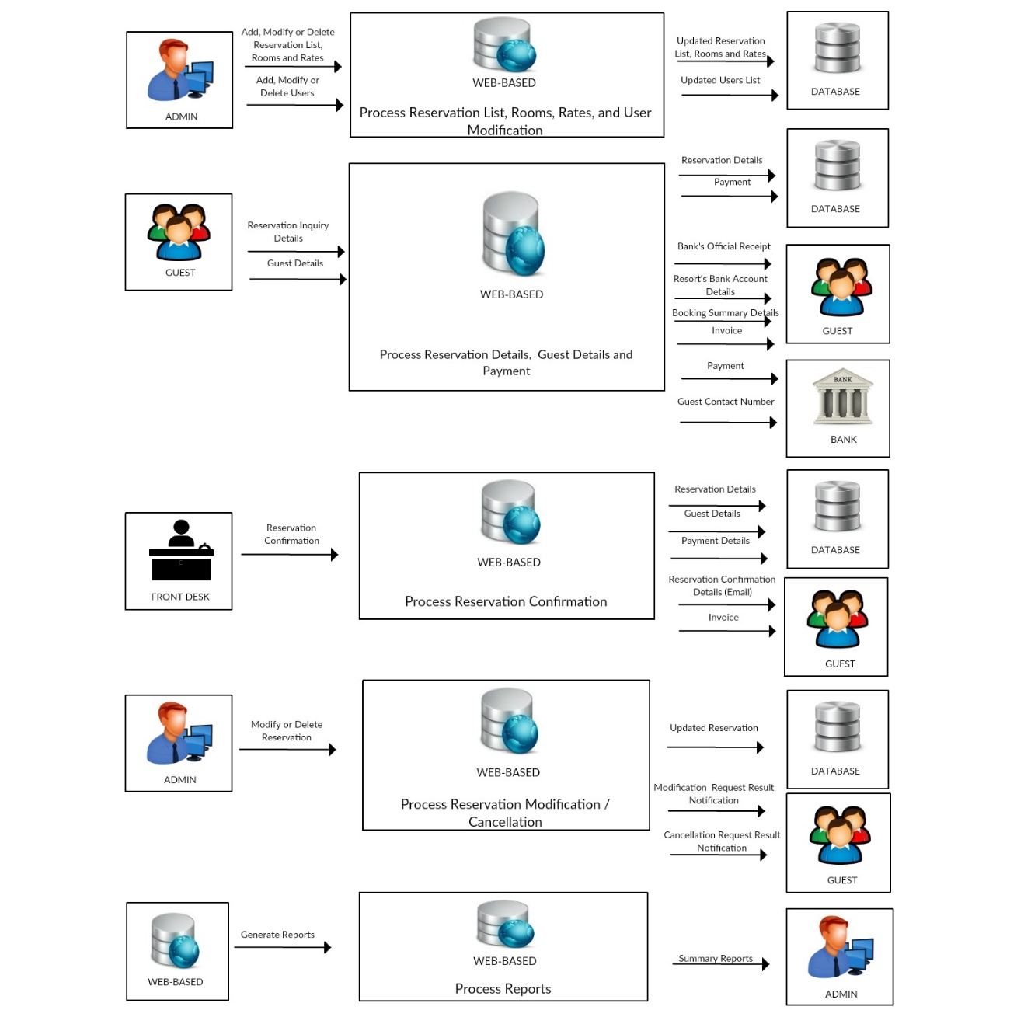***Figure 53: System Framework of the Developed System*

The System Framework consists of a conceptual or graphical structure of all the processes and transactions which is being executed by the developed system. It illustrates the different entities and their roles in a company which may help the movement or flow of transactions.

The developed system, Web-based Reservation and Billing System, can provide the resort’s different information through the website. It also allows guests to reserve available rooms instantly that they would like to pay for in the resort.

The administrator can add, modify and delete a user in the system, also can add, modify and delete resort’s details such as room rates and details of rooms.

Guests should provide their reservation details such as the check-in date, check-out date, and number of adults and children. Then, guest will select a room of his or her own choice. After that, the guest needs to provide his or her personal information. Next, guests will proceed to payment and will select his or her preferred type of transaction. The type of transactions are down payment and full payment which guests must pay for their payment through bank deposit. Afterwards, the system will integrate the complete and summarized reservation details together with a reservation number and mark or block the date of the guest’s reservation and an invoice will be printed by the guest within the system.

The front desk staff can approve or confirm guest’s reservation. The guest will first send his or her bank official receipt with the reservation number via resort’s email or Facebook account. After confirming, the front desk staff will now give a new invoice and a reservation confirmation sent through guest’s email that will be presented upon check in.

The guest can modify his or her reservation and the modifications will then be processed as requested by the guest. Thus, the administrator will reply to any inquiries or messages sent by the guest at a given time and will give the result to the guest’s that wants changes on his or her reservation. The system gives permission or advise for guest to automatically modify his or her own reservation.

The web-based system will generate all the reports of the resort which a summary of these reports will be passed onto the Administrator.

**Context Diagram**

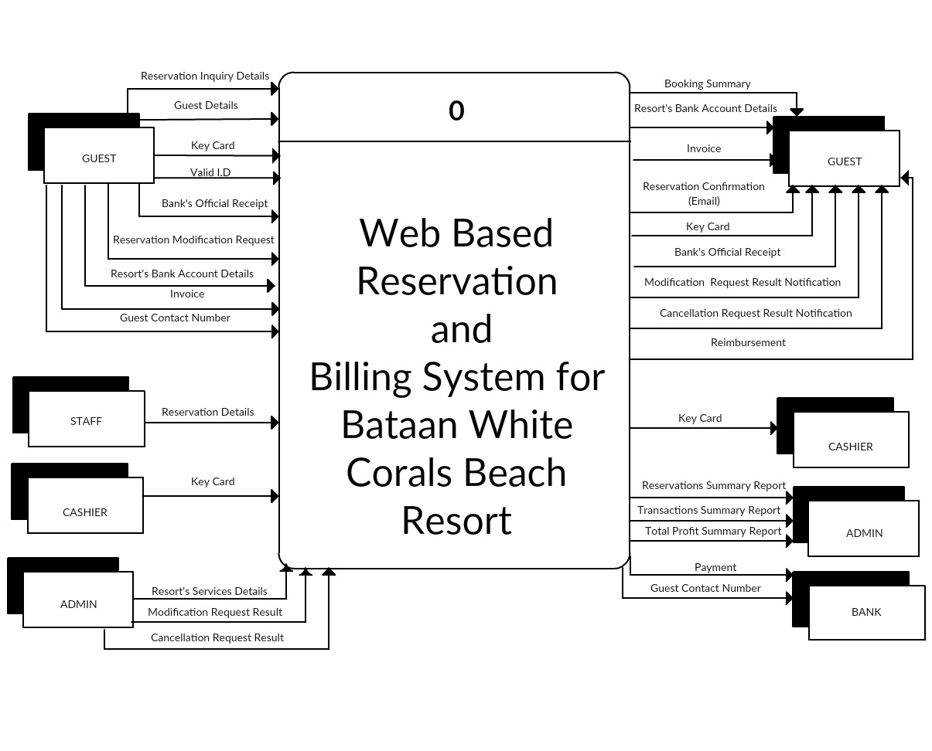

*Figure 54: Context Diagram of the Developed System*

In this figure, the Context Diagram of the developed system illustrates how the entities and web-based system interact with each other and it also shows what entities send and receive data that are flowing in and out of the system.

The Guest entity is one of the main sources of data in the system. The guest will inquire available reservation of his or her desired dates, room(s) or services. After confirming the availability of dates, room(s) or services, the guest will provide his or her personal information which is needed for the completion of transaction. Then after filling-up required guest details, the guest will directly go to the billing details of his or her reservation along with the summary of reservation details. the guest will select or choose a type of transaction which is the down payment or full payment through the resort’s BDO account with a given deadline. After depositing the payment to the resort’s bank account, the bank will provide an official receipt for the guest. The official receipt, will be scanned and sent by the guest to the resort’s email address or Facebook account for the confirmation of the reservation. Once the transaction is successfully finished, a reservation confirmation details will be sent via email to the guest which will be presented upon guest’s check-in at the resort. After the reservation has been approved, the guest can view its reservation details by logging in with his or her email address and the provided reservation number by the system. The guest can also print their invoice directly to the system if they do not want to print it from their email. In terms of guest’s modification/cancellation request, the guest can log-in to the system using the transaction ID and the used email. Modifying the reservation, the guest will be notified and the system will process the modifications requested by the guest. In the cancellation process, the administrator will be the one to decide whether the cancellation of the guest’s reservation has a valid reason also will confirm the reimbursement and the cashier will return the paid amount to the guest.

The staff is one of the entities that will confirm or approve the guest’s reservation and will give an invoice and reservation confirmation through email. Then upon check out of guest, the cashier will receive the key card given by the guest before leaving the resort.

The administrator is also considered as the major entity in the developed system, the admin will be the one to manage the content management module which can add, edit or delete rooms, amenities, and user information in the system.

Reports such as total reservations, total transactions, and total profit will all be computed and compiled by daily, monthly and yearly. The reports will be received and seen by the administrator.

**Diagram 0**

***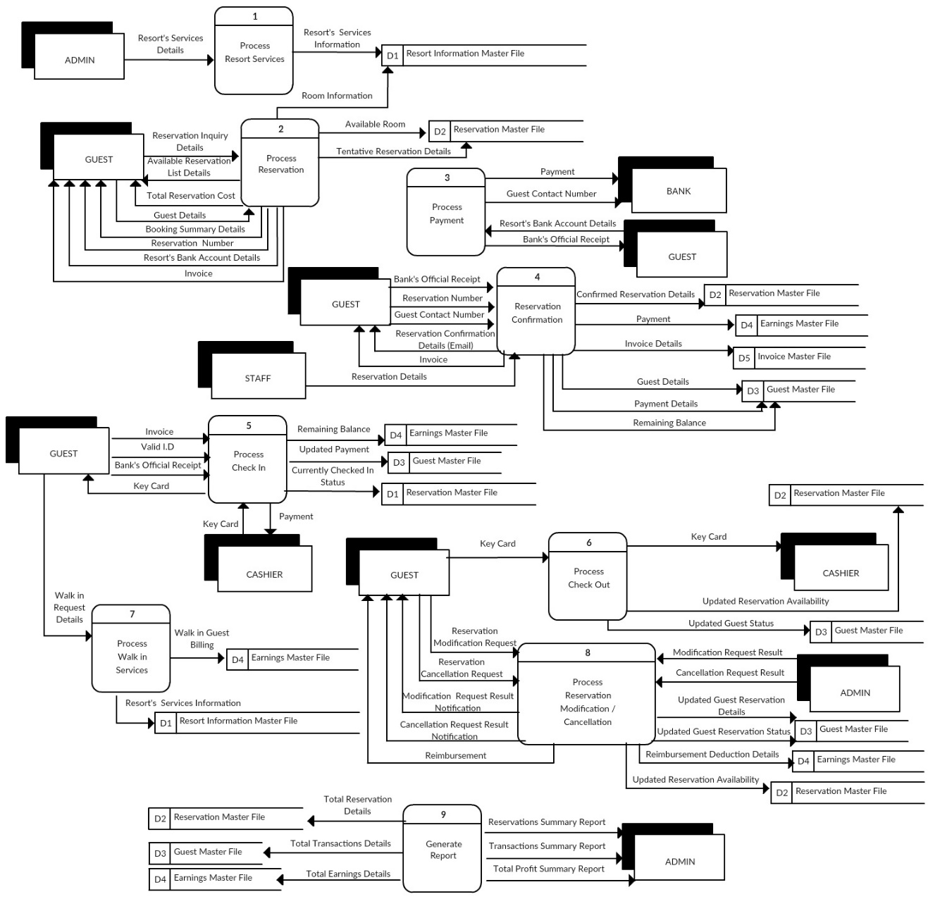****Figure 55: Diagram 0 of the Developed System*

The first process is the Process Resort’s Services wherein the administrator manages the content management module, where he or she can add a new room, cottage, amenity, services and rates together with its complete information. This information can be seen at the resort’s website and used in determining the guest’s reservation details. He or she can also modify its contents and delete if it’s not available or necessary anymore.

The second process is the Process Reservation which is for the guest who are visiting and browsing the resort’s website and to proceed or make an online reservation. The guest can reserve available rooms or services in the resort’s website, which will be applied from the Reservation Master File, the available room will be displayed. Also, the Resort Information Master File will be displayed, which the guest will know the prices, packages and rates or the room information while he or she is making a reservation. The guest should provide the reservation details such as check-in date, check-out date, number of adults and children also the room or rooms that the guest needed to validate the reservation’s availability. Along with this process, the guest is required to give his or her personal information in the system. Then the tentative reservation details will be stored in Reservation Master File. The personal and contact details will be stored on the Guest Master File. After that, a reservation number, booking summary details will be displayed as well as the total reservation cost of the guest’s reservation. The resort’s website will also give their BDO bank account details where the guest will deposit his or her payment. Then the guest will also receive an email notification regarding their reservation details including the reservation number, booking summary details, total reservation cost and invoice.

The third process is the Process Payment, after validating the guest’s complete reservation details from the third process. The guest will select his or her desired type of transaction which is if it is a down payment or full payment. Guests can send their payment through bank deposit. The guest must deposit or go to the BDO bank and provide their contact number and the given bank account details of the resort before he or she deposits the payment. An official receipt will be issued to prove that he or she has deposited the cash.

The fourth process is Reservation Confirmation, the bank’s official receipt together with the reservation number which the guest will write onto the receipt will be scanned and sent by the guest through the resort’s email address or Facebook account for confirmation and present upon check-in. Once the transaction succeeded, an invoice and reservation confirmation details will be sent via email to the guest which will be presented upon guest’s check-in for validation. Then the staff will update and confirm the Reservation Master File that the guest has deposited an amount of payment for his or her reservation. Guest Information and payment details will also be stored to the Guest Master File with the remaining balance of the guest, if guest uses down payment transaction. Earnings Master File wherein the staff will input the guest’s payment. The staff will also update and give the guest a new invoice through email wherein it will indicate the updated invoice details which is reflected upon guest’s official receipt.

The fifth process is the Process Check-in, the guest must present the invoice sent through email after the guest paid the down payment or full payment as well as presenting their valid I.D and the bank’s official receipt to the cashier for validation purposes which is from the Guest Master File. After the validation of the invoice, confirmed reservation details, valid I.D and the bank’s official receipt as well as the remaining balance has been paid if there’s any. The cashier may give the key card to the guest and can now use the reserved room or rooms that he or she avails. The given key card has the access to the guest’s room. The room information in the Reservation Master File will be updated and change the status of the room which is occupied. The status will be shifted from reserved to currently checked-in.

The sixth process is the Process Check-out, wherein the guest leaves his or her room and will return the key card to the front desk staff. The guest will also be asked to fill-up a Registration Form for the terms and condition of the resort and serves as the official receipt. The original copy will be for the guest and a duplicate for the resort, and it will be stored to the Invoice Master File. After filling-up the registration form. The cashier will record the Check-out information of the guest. The Reservation Master File will be updated which the room status will be updated and become available again for another reservation and the Guest Master File will be updated which the guest’s status.

The seventh process is the Process Walk in Services, where the guest will avail cottages and amenities such as cabana, videoke, banana boat, island hopping and kayaking at the resort. The cottages and amenities are first come, first served basis. Thus, guest’s payment will be stored or recorded in the Earnings Master File.

The eight process is the Process Reservation Modification / Cancellation, where the guest can request changes with his/her reservation by informing the resort to modify their reservation details, it may be the dates, rooms, or it can also be both. But the request’s validity also depends on the availability of room or rooms and dates. The guest can also cancel his or her reservation providing a valid reason. Once the request is approved by the management, reimbursement will be given to the guest. The guest may choose whether the return of his/her cash or payment is via bank or in person. After the approval of the management about the guest’s request, the Earnings Master File, Guest Master File and the Reservation Master File will be also updated.

The ninth process is the Generate Report, such as Transactions Summary Report, Reservations Summary Report, and Earnings Summary Report. These are the results of all processes and transactions done by the resort. The reports will be received by the Administrator.

**Child Diagram**

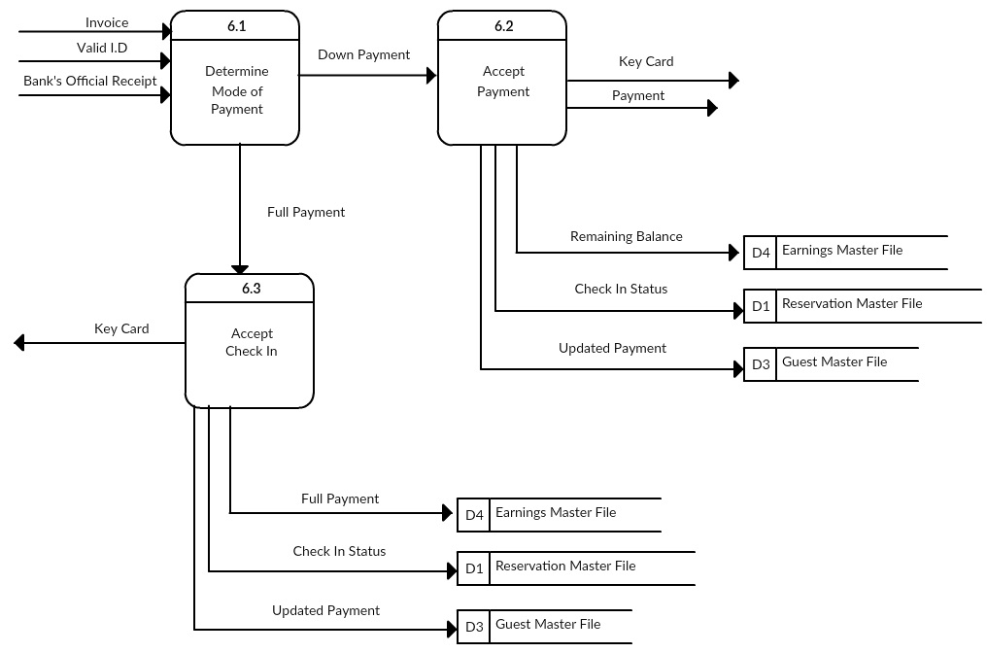*Figure 56: Child Diagram Process 6: Check in Process*

The diagram shows about the child diagram of Process 6, Process Check in. Process 6.1 includes and determines the mode of payment which guest may use whether if it’s a down payment or full payment transaction. To process or use the down payment, Process 6.2 Process Down Payment Transaction, guest must pay at least 50% of their remaining balance. After paying the initial payment, the cashier will give the key card to the guest. The Earning Master File will be updated and store the remaining balance of the guest, the Reservation Master File will be updated and change the status of the room. The status will be shifted from reserved to currently checked-in. the Guest Master File will also be updated which it will store the status of the guest’s payment. While to process or use the full payment, Process 6.3 Process Full Payment Transaction, the guest will also pay for their bill but in a full payment procedure. After paying the full payment, the cashier will give the key card to the guest. The Earning Master File will be updated and store the full payment of the guest, the Reservation Master File will be updated and change the status of the room. The status will be shifted from reserved to currently checked-in. the Guest Master File will also be updated which it will store the status of the guest’s payment.

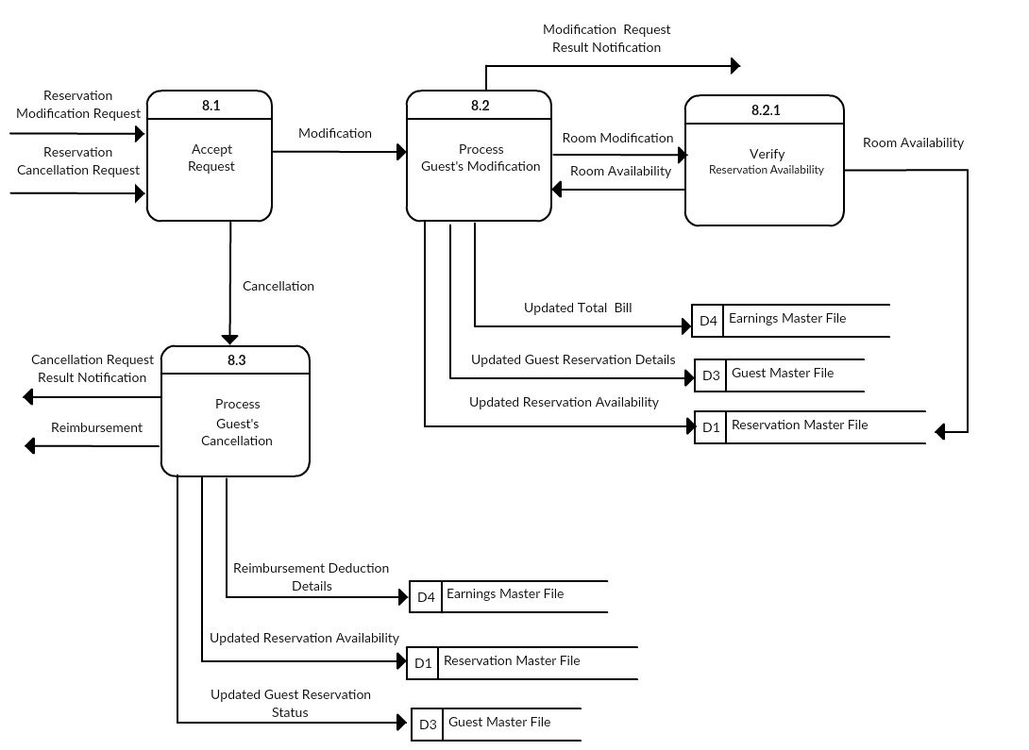

*Figure 57: Child Diagram Reservation Modification / Cancellation Process*

The diagram shows about the child diagram of Process 8, Process Reservation Modification/Cancellation. Process 8.1 includes and accept the request of guest which guest may use whether if it’s a modification or cancellation request of reservation. To process or use the modification Process 8.2 Process Guest’s Modification, guest must first request or notify changes with their reservation by informing the resort to modify their reservation details. The guests’ request’s validity also depends on the availability of room or rooms which will be first check or verify in the Process 8.2.1. Once the room is available for reservation, the guest will automatically be notified via guest’s email. Then the Earnings Master File, Guest Master File and Reservation Master File will be updated. But once the room is not available for a reservation, guest will also be notified via email that their requested modification is or are not applicable. While to process or use the modification Process 8.3 Process Guest’s Cancellation, the guest must indicate or provide a valid reason to cancel his or her reservation. Once the request is approved by the management, the guest will be notified via email and the guest’s payment will be refundable. After the approval of the management about the guest’s request, the Earnings Master File, Guest Master File and the Reservation Master File will be also updated.

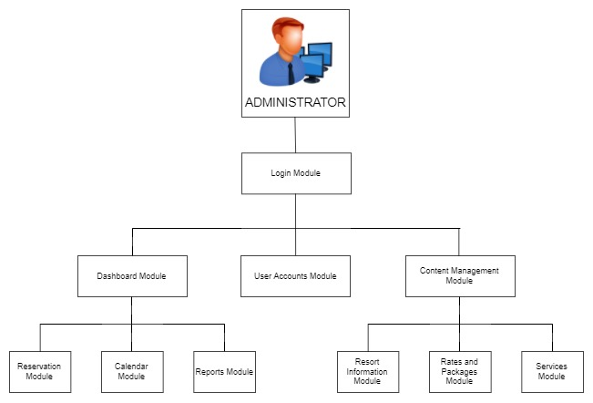*Figure 58: Hierarchy of the Admin Module*

* Only the administrator can add, modify and delete the contents of the website through Content Management Module. Under the Content Management Module has Rates and Packages Module includes room and packages rates or prices also Services Module include rooms, cottages, amenities and other services offered by the resort.
* Only the administrator can add, modify and delete users such as the front desk staff in the User Accounts Module.
* The administrator can view reports, calendar, and reservation in the Dashboard Module. The administrator can mark the calendar on a specific day whether it is available or not for reservation. Also, if the resort is open or close on a particular day, and has an upcoming holiday for that week or month.

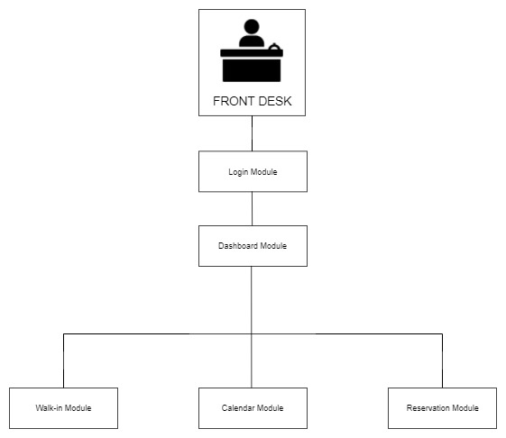

*Figure 59: Hierarchy of the Front Desk Module*

* Only available for the front desk to view and also modify is the Dashboard Module which consists of Calendar Module, Reservation Module, and Walk-in Module unlike with the Administrator it manages or controls all the modules.

**E-R Diagram**

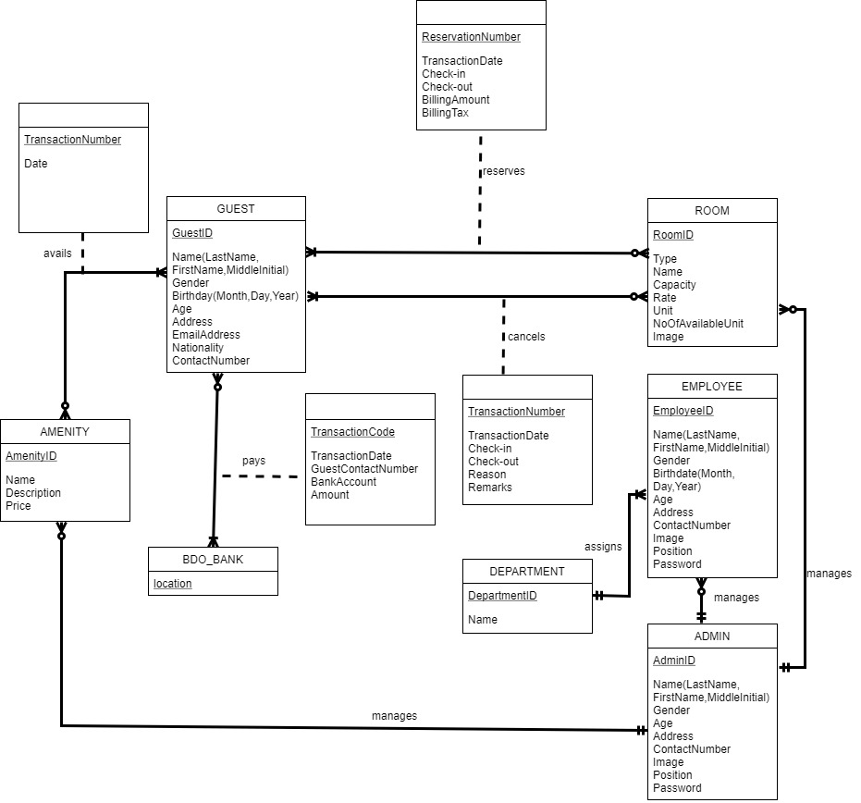

*Figure 60: E-R Diagram*

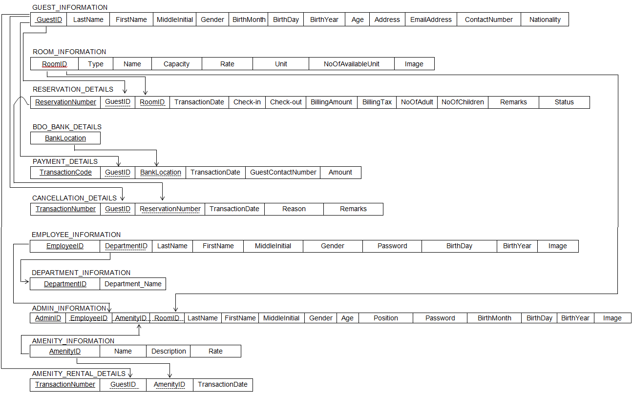**TABLE FORM NORMALIZATION**

*Figure 61: Table Normalization*

**CONSTRAINTS, ASSUMPTIONS, RIKS AND MINIMIZATION MEASURES**

|  |  |  |  |
| --- | --- | --- | --- |
| CONSTRAINTS | ASSUMPTIONS | RISK | MINIMIZATION MEASURES |
| *TIME* | Able to effort and time to finish the project on time. | Due to limited time, there’s a possible that the project will not be finished on expected date. | Maximize meetings and give the specific job assignment of each member and set a deadline for each task. |
| *BUDGET* | The group should have funds in order to finish the project. | The other member of the group has no budget for the other expenses of the project. | Budget project cost. |
| *LOCATION* | Able to go to the company if there are needed for the project. | The company’s location is far so it’s hard for the group to visit. | The group will do the limit visits and organize all requirements needed for the project. |
| *SKILLS* | Inherent knowledge and skills in order to finish the project. | The group has insufficient knowledge to finish the project. | The group will conduct research and study, consult experts and practice coding. |

Table 2: Constraints, Assumptions, Risks, Minimization Measures

Table 2 shows the constraints of the developed project, assumption, risks and minimization measures uncovered in the undertaking of this study. Constraints are the boundaries and limits which must worked on by the proponents. Assumptions are positive statement that organize and indicated the solution to the constraint in order to finish the project. Risks are the worst problems of the group, risks are also the threats of unsolved constraints. Minimization measures are the actions for the risks to lessen and eliminate.

**Time**

Since the group has limited time to finish the project, the risk was the incompletion of the given project. In order to finish the project the proponents gave more efforts and more time to work on to lessen the risk. And also the proponents have their different tasks and set a deadline for it and to manage and organize all the requirements needed before the deadline of the project.

**Budget**

It was considered as one of the constraints. The proponents should have a budget for the project. As the project progresses the monetary need increases. They need to manage properly the funds that they have and make sure that everyone on the group should contribute equally to lessen the monetary burden.

**Location**

It was one of the risks of the proponents. Since the company’s location is far, the proponents have a limited time to visit. The assumption was that they were able to go to the company if they needed. The minimization measures were that the proponents will do the limited visits to the company and they need to organize clearly all the requirements for the project.

**Skills**

It was very important since; it was one of the needs of the proponents to complete the project and can determine the output and success of the project. The minimization measures are that the proponents should conduct research and study and practice coding for the project to accomplish.

**PROJECT SCHEDULE**

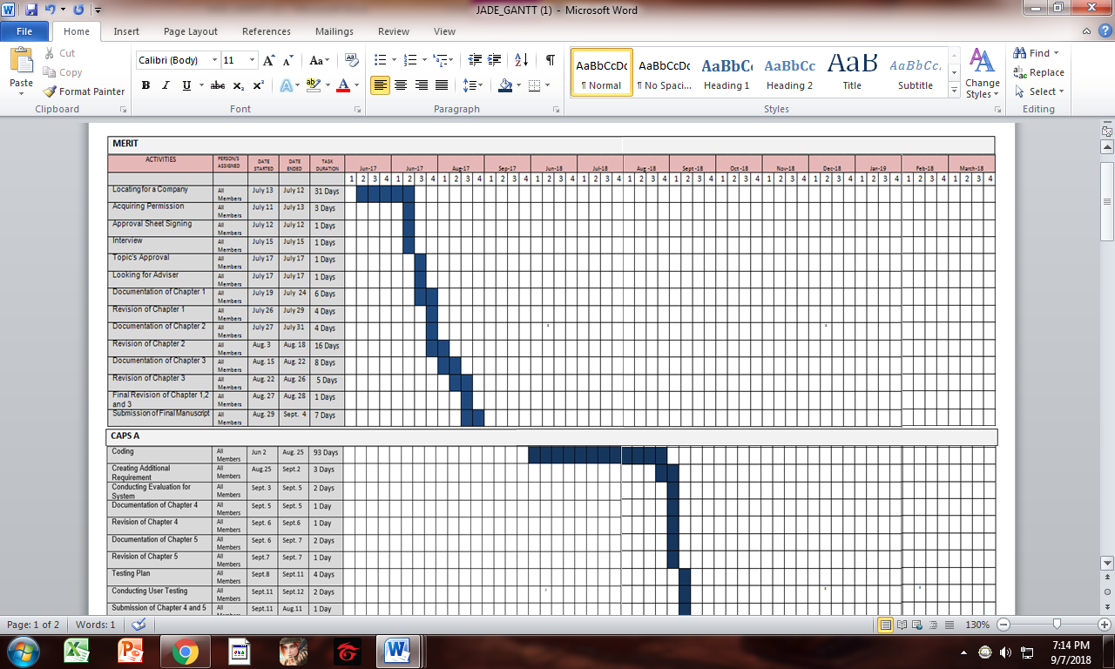

*Table 3: Gantt Chart*

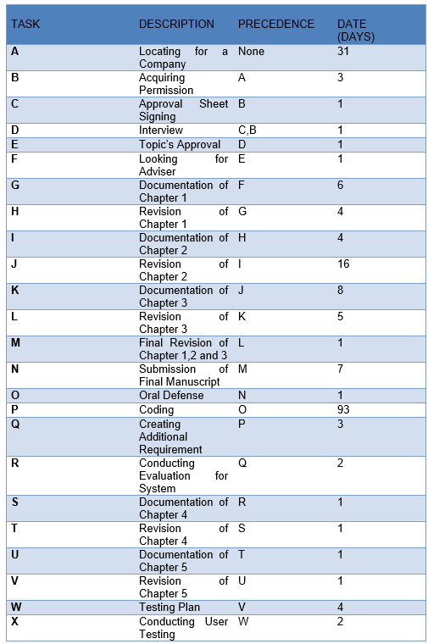

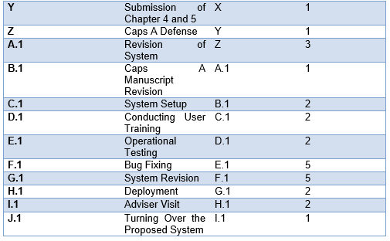

*Table 4: Pert Diagram*

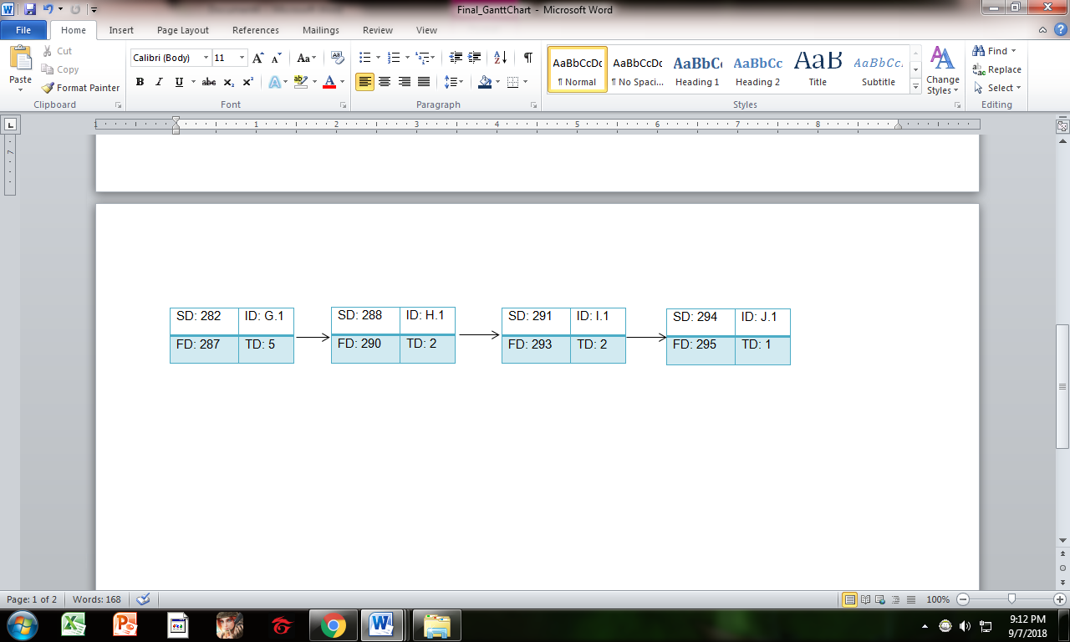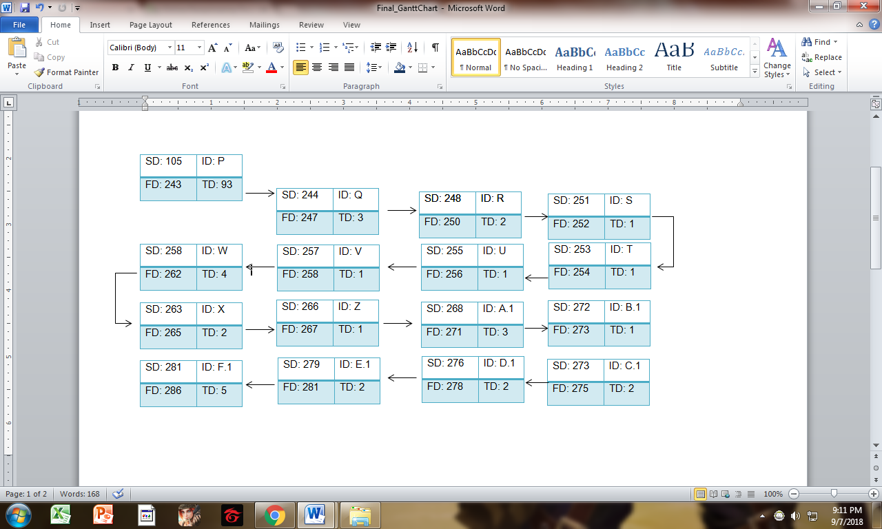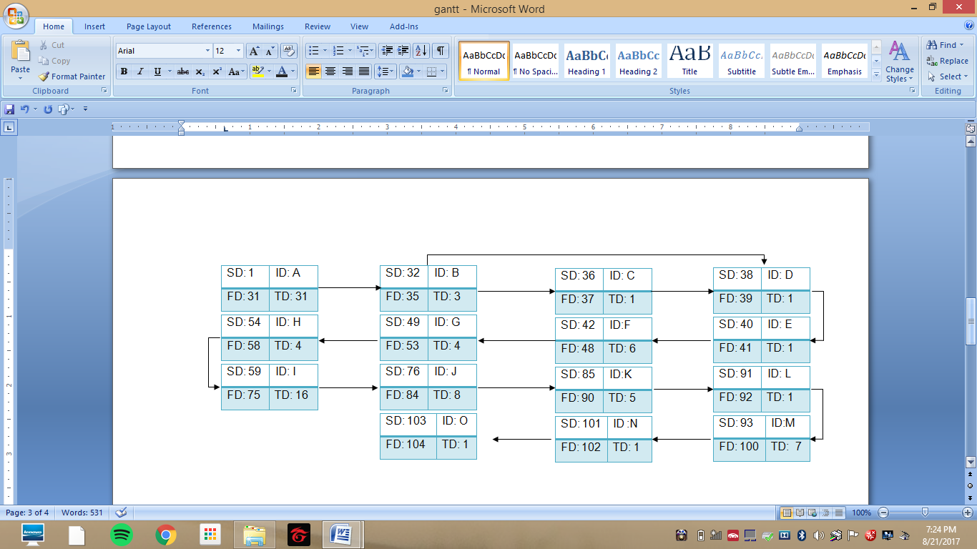

*Figure 62: Pert Diagram*

**Testing and Evaluating Procedure**

After developing the system, the group will have a procedure for testing and evaluating the system. This section discusses how testing and evaluation is done.

* *STEPS IN CONDUCTING THE TESTING*

An orientation was conducted for the owner of the resort, manager, staffs and users for the functionality of the developed system, the orientation will do before the testing of the system that was developed by the group. After the orientation, the evaluation sheet was given to them to fill up the evaluation form.

The testing and evaluation of the developed system were divided into two parts. The first part of the evaluation, the owner of the resort and the manager who tested the whole system and its modules for how many times until the satisfaction has met. On the second part, the user was invited together with the other staff to test if the system conformed to the requirements.

* *THE CLIENT SHOULD TEST THE SYSTEM*

The developed system was evaluated and tested by the manager, other staffs and selected users of the Bataan White Corals Beach Resort.

The project was tested and evaluated by the owner of the Bataan White Corals Beach Resort. The developed system was tested by the following: one (1) front desk module for the receptionist or reservation officer account, one (1) admin level for the admin account, ten (9) students who are taking up IT and ten (10) IT professionals. This is to check if there are errors and bugs in each of the module so it will be fixed, and if there are any more suggestions or comments for the system.

* *EVALUATION INSTRUMENT*

An evaluation was conducted to the specific users to test the content, functionality, availability, reliability and maintainability of the developed system. It was tested using the Five Point Scale System in rating which is shown below.

|  |  |  |
| --- | --- | --- |
| Rating | Range | Verbal Interpretation |
| 5 | 4.51-5.00 | High Acceptable |
| 4 | 3.51-4.50 | Acceptable |
| 3 | 2.51-3.50 | Moderately Acceptable |
| 2 | 1.51-2.50 | Slightly Acceptable |
| 1 | 1.00-1.50 | Not Acceptable |

*Table 5: Five Point Scale System*

Table 5 is the criteria for the evaluation, it was given and discussed to the direct user of the Web-Based Reservation and Billing System for Bataan White

Coral Beach Resort are the following:

1. **Content** – refers to the overall system and updated of the content.
2. **Maintainability** – a set of attributes that bears on the effort needed to make specified modification, which may include corrections, improvements, or changes in the requirements.
3. **Availability**- the proportion of time the develop system is in a functioning condition.
4. **Functionality**- the extent to which the develop system can be expected to perform its extended function.
5. **Reliability**- the capability of the developed system to maintain its performance level under stated conditions for a stated period of time.

* *STATISCAL TREATMENT OF DATA*

This section discusses the mathematical operation that was used after the testing and evaluation of the system. It was used to compute the ratings of the direct users for the project will be Mean more known commonly as the average.

**FORMULA:**

X =

**X**

n

Where:

**X** (sometimes call the X-bar) is the symbol for the mean.

**ΣX is the sum of respondents’ rating**

**n is the symbol for the total number of respondents.**

**EVALUATION FORM FOR WEB-BASED RESERVATION AND BILLING SYSTEM FOR BATAAN WHITE CORALS BEACH RESORT**

**Name:** ___________________________________**Date:** __________________

**Position:** ______________________________________

**Company Name:** _______________________________

**Administered:** _________________________________

**INSTRUCTION:** With the use of given scale shown below, evaluate the system. Place a check mark (✓) under the column matching numerical rating:

**5- Excellent 4- Very Satisfactory 3- Satisfactory 2- Fair 1- Poor**

|  |  |  |  |  |  |
| --- | --- | --- | --- | --- | --- |
| **SOFTWARE CRITERIA** | **5** | **4** | **3** | **2** | **1** |
| 1. Content |  |  |  |  |  |
| 1. Content Presentation |  |  |  |  |  |
| 1. Clarity and Originality of Content |  |  |  |  |  |
| 1. Functionality |  |  |  |  |  |
| 1. Accuracy |  |  |  |  |  |
| 1. Ease of Operation |  |  |  |  |  |
| 1. Friendliness of the system |  |  |  |  |  |
| 1. Availability |  |  |  |  |  |
| 1. System completeness |  |  |  |  |  |
| 1. Standard security of the system |  |  |  |  |  |
| 1. System performance |  |  |  |  |  |
| 1. Reliability |  |  |  |  |  |
| 1. Recoverability of the data |  |  |  |  |  |
| 1. Accuracy |  |  |  |  |  |
| 1. Quality of the system |  |  |  |  |  |
| 1. Absence of error |  |  |  |  |  |
| 1. Maintainability |  |  |  |  |  |
| 1. Testability |  |  |  |  |  |
| 1. Easy Maintenance |  |  |  |  |  |
| 1. Maintainability of the Standard |  |  |  |  |  |

|  |  |
| --- | --- |
| Summary | Average |
| 1. Content |  |
| 1. Functionality |  |
| 1. Availability |  |
| 1. Reliability |  |
| 1. Maintainability |  |
| **Total Score** |  |
| **Equivalence Meaning** |  |

COMMENTS AND SUGGESTIONS:

___________________________________________________________________________________________________________________________________________________________________________________________________________________________________________________________________________________________________________________

_______________________

Evaluator’s Signature